Chapter No 8

SOFTWARE AND PROGRAMING LANGUAGES

SOFTWARE:

DEFINITION:

“A piece of software is a computer program which has been written to carry out a particular task.”

“A set of instruction to solve a particular problem”

Without software the hardware that is used to build a computer system would not be very useful. A software program contains the instructions that the computer must follow to carry out the task. Sometimes more than one program is required to complete a task. When this is the case the group of programs which together complete the task are known as a software package.

Software programs are originally produced by computer programmers who will write the instructions that form the program in a programming language.

Example pieces of software are:

A word processor.

A multimedia encyclopedia.

A spreadsheet.

TYPES OF SOFTWARE
A software is usually classified as being two types
- Systems software
- Applications software.
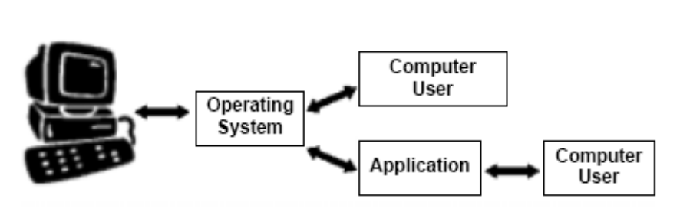

SYSTEM SOFTWARE

Systems software controls the operation of a computer. Without systems software a computer would not function. The most important piece of systems software is the operating system. The operating system will perform vital tasks such as:

Managing communications between software and hardware.

Allocating computer memory to other software programs.

Allocating CPU time to other software programs.

TYPES
- Operation systems
- Utility program
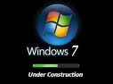

- Programming languages
- Device drivers
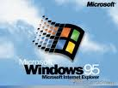

APPLICATION SOFTWARE

DEFINATION:
“Application software consists of programs designed to perform specific tasks for users”.
Application software can be used as a productivity/business tool; to assist with graphics and multimedia projects; to support home, personal, and educational activities; and to facilitate communications.
TYPES:
- Word Processor
- Presentation Software
- Database
- Spreadsheet
- Communication software
- Desktop Publisher
- Graphics Package

